An Innovative SMS Based Voting System

S.Abishek, S.Arun Kumar, P. Deepak

Department of Computer Science and Engineering,
Misrimal Navajee Munoth Jain Engineering College,
Jyothi Nagar, Thoraipakkam,
Chennai – 97.

abishek725748@gmail.com, arun.cse016@gmail.com, pdeepak22@gmail.com

Abstract: The Voting process takes place to select a leader, a representative of the people, who will lead the nation. It is the duty of every eligible citizen to cast their votes in the election process. In the existing systems, voting process is done through paper ballot system. In recent years, electronic voting system was introduced and is being used more and more. Electronic voting system provides convenience and access to the electorate, making the vote backup and counting process a lot quicker and easier. But in these voting systems people have to wait in long queues to cast their votes and also implementing this method is very expensive and time consuming. This is pretty evident from the very low vote outcome percentages every year. This situation is more prevalent in urban city centres and also to an extent in rural areas; the non-voting percentage of citizens find it hard to allocate time to exercise their national duty (for example, IT professionals who would rather go to work to earn extra money, than to wait in long queues). Also, apart from the before mentioned main issue, there are other obliterating problems such as Security issues, vote database constraints, Unwanted crowding and mobs in public places, etc. So, in order to eliminate the issues in the existing voting system we introduce a new system of voting through SMS. The proposed system is highly reliable, secured and cost effective. Any registered individual with any type of mobile phone can use it to cast their votes.
We have a secured method of allocating each individual with a unique ID corresponding to their voter ID and phone number, so that no fraudulent doings can be done. The total proposed system can be integrated along with the existing election process so that higher vote outcome can be achieved among other critical benefits, and in the future, the existing system can be shifted to the proposed one, to completely mobilize the Voting System.

Keywords: AES, Camellia, Election Website, SMS Gateway, Nominees, SMS, Voting.

- INTRODUCTION

Election and voting are well known things in modern days of Democracy. It has become the most formal method of forming a government in all people run countries. Leaders compete against each other, and try to win the votes of their people. Earlier, the election and voting process happened legally and without and problems or fraudulent operations. But as time passed by, the leaders started recognizing the power of the political seats and began involving in illegal mechanisms to secure their votes. This has led to false votes and other worse problems in the election system. This in turn has caused a disinterest in the minds of today’s citizens, who would rather mind their day today work than involve in a national duty and procedure. Also people want an easy and innovative way to exercise their duty, which doesn’t interfere with their daily activities. At later stages, many improvements were made and are being made to curb the illegal activities happening in the voting process. This has led to considerable constraining of the malpractices undertaken in election system, but still no complete correction of the bad practices. Never the less, the disinterest of the citizens, especially in the urban side has not declined. People still find it hard to spend time to cast their votes. The vote outcome percentages are coming down every year. Government Specialists and other officials are always thinking of new methods and ways to monitor this potential problem and bring a positive outcome in coming years. A wide range of empowering rallies and advertisements are being organized from time to time, aiming at changing the minds of the citizens. Also new methods of facilitating the election system have been introduced at regular intervals. The Paper Ballot systems were introduced when the count of the people eligible to vote increased drastically. Elections were conducted in phases. Later on, the Electronic Voting Systems were introduced to tackle the hard comes of Paper Ballot System. The systems do not address the problems faced by the citizens efficiently. Recently a number of e-voting systems and internet voting systems have been proposed, but none seem too trust worthy and none maintain integrity.
In this Paper, We propose SMS BASED VOTING SYSTEM, a new and innovative way to conduct the election system, which also maintains the integrity and security of the process. It adapts all positive efforts from the previous systems and also eliminates the disadvantages of those systems and introduces new, error free and easy mechanisms to conduct election. This system is designed to accept only one vote from a single voter, who will be registered with a specific phone number of choice and also is accessible to anyone with any basic mobile phone with SMS facilities.
This Paper is organized as follows.
- Section II presents Literature Review in which elections are defined and three types
of voting systems are presented.
- Section III presents the System Design, explaining every module in detail.
- Section IV presents the various phases in the proposed system working process.
- Section V presents the implementation screen shots and important code section.
- Section VI, the final section presents the Conclusion and Ideas for future improvements.

- LITERATRURE SURVEY

Citizens of a nation come together to elect their representatives, who will implement the interests of his/her people. An election is a formal decision-making process by which a population chooses an individual to hold public office. Elections have been the usual mechanism by which modern representative democracy has operated since the 17th century. Processes similar to modern democratic elections were even seen in practice at time as old as 1000 -2000 B.C., in ancient Greek and Roman empires. Elections may fill offices in the legislature, sometimes in the executive and judiciary, and for regional and local government. This process is also used in many other private and business organizations, from clubs to voluntary associations and corporations. The universal use of elections as a tool for selecting representatives in modern democracies is in contrast with the practice in the democratic archetype, ancient Athens. As the Elections were considered an oligarchic institution and most political offices were filled using sortations, also known as allotment, by which officeholders were chosen by lot. Electoral reform describes the process of introducing fair electoral systems where they are not in place, or improving the fairness or effectiveness of existing systems. Psephology is the study of results and other statistics relating to elections (especially with a view to predicting future results). To elect means "to choose or make a decision", and so sometimes other forms of ballot such as referendums are referred to as elections.
The question of who may vote is a central issue in elections. The electorate does not generally include the entire population; for example, many countries prohibit those judged mentally incompetent from voting, and all jurisdictions require a minimum age for voting. Suffrage is typically only for citizens of the country, though further limits may be imposed. However, in the European Union, one can vote in municipal elections if one lives in the municipality and is an EU citizen; the nationality of the country of residence is not required. In some countries, voting is required by law; if an eligible voter does not cast a vote, he or she may be subject to punitive measures such as a fine.
There are two major methods of Voting used all over the world. They are, Manual Voting (Paper ballot) and Electronic Voting. A third method, by making use of internet and smartphones is being increasingly proposed at world governments.
MANUAL VOTING:

Paper based Ballot System was the first voting method, and is the oldest, having been used for many centuries. In spite of its shortcomings, it was considered the only way to vote, as there was no successful alternative. Manual counting requires a physical ballot that represents voter intent. The physical ballots are read and interpreted; then results are individually tabulated. The party and candidate names are pre-printed on the ballot, or the voter can write them in on a blank ballot. When voting has finished, all envelopes are opened on the counting table, for one election at a time. They are sorted in piles according to party, inspecting them for validity. The piles are then counted manually, while witnesses around the table observe. The count is recorded, and the same pile is counted again. If the results do not agree, it is counted a third time. When all piles are counted and the results agree, the result is certified and transmitted for central tabulation. The count as received is made public, to allow anyone to double-check the tabulation and audit the raw data. There was a high level of confidence in this system among the population, as evidenced by the early lack of criticism of it. Such a system may be used for recounts in areas where mechanical or automated counting systems are used. However, the traditional methods, with all their diversity in terms of the means of voting, are still problematic. As mentioned before, since the votes are gathered and counted by hand, there is a strong likelihood of the occurrence of errors.

ELECTRONIC VOTING:

Electronic voting is voting using electronic systems to aid casting and counting votes. Electronic voting technology can include punched cards, optical scan voting systems and specialized voting kiosks (including self-contained direct-recording electronic voting systems, or DRE). In general, Electronic voting is normally physically supervised by representatives of governmental or independent electoral authorities (e.g. electronic voting machines located at polling stations). Electronic voting technology can speed the counting of ballots and can provide improved accessibility for disabled voters. However, there has been contention, especially in the United States, that electronic voting, especially DRE voting, could facilitate electoral fraud. Most recently, these systems can include an Electronic Ballot Marker (EBM) that allows voters to make their selections using an electronic input device, usually a touch screen system similar to a DRE. Systems including a ballot marking device can incorporate different forms of assistive technology. In 2004, Open Voting Consortium demonstrated the “Dechert Design” a General Public License open source paper ballot printing system with open source bar codes on each ballot.

Difficulties with Elections
- Lack of open political debate or an informed electorate :
The electorate may be poorly informed about issues or candidates due to lack of freedom of the press, lack of objectivity in the press due to state or corporate control, and/or lack of access to news and political media. Freedom of speech may be curtailed by the state, favoring certain viewpoints or state propaganda.
- Unfair rules :
This can include Gerrymandering, exclusion of opposition candidates from eligibility for office, and manipulating thresholds for electoral success are some of the ways the structure of an election can be changed to favor a specific faction or candidate.
- Interference with campaigns :
Those in power may arrest or assassinate candidates, suppress or even criminalize campaigning, close campaign headquarters, harass or beat campaign workers, or intimidate voters with violence.
- Tampering with the election mechanism :
This can include confusing or misleading voters about how to vote, violation of the secret ballot, ballot stuffing, tampering with voting machines, destruction of legitimately cast ballots, voter suppression, voter registration fraud, failure to validate voter residency, fraudulent tabulation of results, and use of physical force or verbal intimation at polling places.
- Equally this list is only some of the ways in which it can occur, other examples may include persuading candidates into not standing against them. Some examples include: blackmailing, bribery, intimidation or physical violence.

- EXISTING SYSTEM

While Internet voting has been utilized for national-level elections in only a few countries, it is a voting mechanism that is increasingly being explored as a means to allow access to the election process for voters who may otherwise find it difficult to go to their polling location on Election Day. Internet voting, however, presents a number of technological challenges focused on security, privacy, and secrecy issues, as well as challenges for stakeholder involvement in and observation of the process.
Many Voting schemes, that use use internet as the base have been increasingly coming up, both in the national and interational levels. The first use of Internet voting for a binding political election took place in the US in 2000, with more countries subsequently beginning to conduct trials of and/or use Internet voting. A total of 14 countries have now used remote Internet voting for binding political elections or referenda. Within the group of Internet voting system users, four core countries have been using Internet voting over the course of several elections/referenda: Canada, Estonia, France and Switzerland. Estonia is the only country to offer Internet voting to the entire electorate. The remaining ten countries have either just adopted it, are currently piloting Internet voting, have piloted it and not pursued its further use, or have discontinued its use.
Internet Voting is actually a contextual extension of e-voting or Electronic Voting as people call it. In the recent past, many proposals and experimental models have surfaced in various countries, that also use smartphone based voting systems as an addition/alternative to fully internet based election systems. Thus in contextual terms, both Internet based voting and Smartphone Voting are being considered and Implemented as methods of conducting an election iin developed and developing countries. Downloading an election app on your smartphone could someday replace the need to join long lines of fellow voters, and it might make elections work better. Researchers have found that smartphone owners make fewer errors using a mobile voting system than when using traditional voting methods.
The most common Internet and Smartphone voting system problems encountered can be categorized as follows:

1. Environmental factors: These may be internal or external to the organization:
a) Internal: Perhaps the most common problems are the lack of skill in administrating biometric voter registration and staff resistance to change.
b) External: Political leaders may not be interested in the registration process and its accuracy and integrity. Vendors may gain access to a system and corrupt its ability to correctly 93 tally votes or to manipulate the electorate, motivated by money or power.

2. Technical factors:
Many machines have been developed recently with as variety of speeds and levels of efficiency and reliability that can cause delays and failures. Changes in biometric characteristics, such as voices altering with age and fingerprints altering due to skin scratches or the kind of work carried by individuals, can affect the mobile voting process.

3. Human Factors:
Not everyone will be with access to internet or smartphones, but almost everyone will have access to a basic GSM/CDMA mobile phone with SMS facilities. Internet Voting is also unreliable in terms of security; most browsers store secure information unless we manually restrict the browsers from doing so, which in turn is a complicated process to a common non tech person.

IV. PROPOSED SYSTEM

Many previous studies on e-voting systems have focused on facilitating the e-voting. These systems are suffering from various weaknesses such as offline registration, extra hardware cost and compulsory polling places. The Internet Voting Systems that were Introduced and are up and going as experimental projects, also suffer from a number of drawback as mentioned in the previous section. Our system is based on the lesson acquired and analysis of the several issues that play significant role in the earlier e-voting systems and internet voting systems.
SMS voting would be much more profitable for the fact that SMS service is available in all mobile phones with SIM. Many voters would appreciate the possibility of voting from anywhere. However this technology faces certain security threats for its successful implementation in election. In this paper, we attempt to facilitate, and ensure, the integrity of elections by introducing our SMS Voting system, which is capable of performing tasks that can reduce the risk inherent in the voting process, such as the addition, deletion, and alteration of votes and also it makes the counting process very easy. This system is designed to accept only one vote from the voter, check on his/her eligibility, and prevent any attempt to manipulate the vote. It is possible to perform all these operations with nothing more than a mobile phone.

The key features of our proposed Mobile Phone SMS Voting are:
- Eligibility: Only authorized voter allowed to cast their vote.
- Uniqueness: Voter can cast only one vote.
- Accuracy: Election commission server should record the ballots accurately.
- Integrity: No valid votes should be modified, replaced or to be deleted.
- Fairness: The election outcome can be calculated by the system itself in no time and also results can’t be accessed before the official result time.
- Secrecy: No one should be able to find how
Someone voted.
- Cost-effectiveness: Election system should be efficient and affordable.

SYSTEM DESIGN:
The Various Modules of our proposed system are as follows.
- Web Site
- SMS Gateway
- Web Server
- Client Mobile

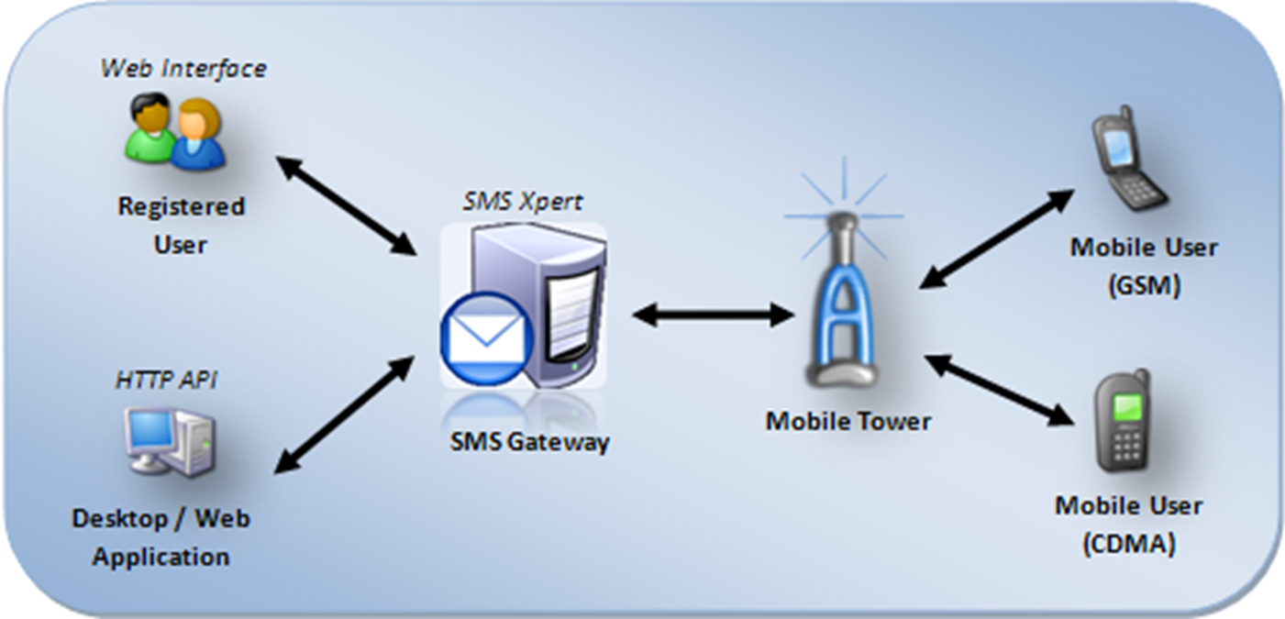
Figure 1: Architecture diagram
1. Web Site
The Website Delivers all functions of the current Pre Voting facilities available manually to voters. It is designed using HTML5 and CSS3 and uses JavaScript. PHP and Reverse AJAX (Comet) are used in the backend. Every function, from registering as a legal voter to checking the updated vote results are available in the web site. The website has 5 Main pages, each with a specific function.
- Administrator Login Page
It is a single login page, with authentication in JavaScript and PHP, which will allow only the system administrators to enter the page. It leads to a set of options that commandeer the SMS gateway mechanisms remotely.

- Candidate Registration Page
The Website also has an online registration page for candidates wanting to nominate themselves for the election. The page retrieves all required details from the nominee and processes them in the background. The website also gets proofs of identification from the candidate to verify that the person is eligible to stand in the election. The page is designed in an easy to use UI and provides all referential help to the user. The details provided by the nominee are validated and processed in the background using PHP and MySql. The ID Proofs are stored in the web server to be checked for further validation. Once all validation and Verification is complete, the Candidate will be provided with a Candidate ID which will be the nominee’s sole identification in the election voting process. People who chose to vote for a particular nominee will have to use the nominee’s Candidate ID.

- Voter Registration Page
The Voter registration Page is similar to the Candidate registration page. It retries similar required details from the registering voter also with Proofs of Identification. Background processing is done using PHP and MySql. After all validation and Verification are completed, the Voter ID will be issued to the registering user at the address provided during registration.

- SMS Vote Registration Page
This is the main page of UI in the proposed system. It requires the user to provide the voter ID and also a mobile phone number which will be used by the user to vote during the Election Day. The proposed system is designed in such a way that only a single number can be accepted from a single eligible voter. Extensive validation and verification are done to ensure that there will be no duplicates or fraudulent details in this module. Once the identity and uniqueness are confirmed, the user will receive a message in the phone number provided during the process. The message will contain a Unique ID individual to the user, which must be used during the SMS voting process. It is very important that the unique ID is not shared with anyone else, and remains highly confidential to the user to facilitate misuse of votes.

- Result Page
The result page provides option to view region wise election results on the day they are announced, along with detailed poll outcomes.

2. SMS Gateway
The SMS Gateway is the brain and backbone for the entire system. It is a highly secured, remote and autonomous entity which controls and manages the entire voting process
Gateways, also called protocol converters, can operate at any network layer. For example, the computers that control traffic between company networks or the computers used by internet service providers (ISPs) to connect users to the internet are gateway nodes. On an IP network, clients should automatically send IP packets with a destination outside a given subnet mask to a network gateway. An SMS gateway allows a computer to send or receive Short Message Service (SMS) transmissions to or from a telecommunications network. Most messages are eventually routed into the mobile phone networks. An SMS gateway typically sits between the end user who needs to send/receive SMS and a mobile network's SMSC. Such gateways provide a choice of protocols, including HTTP, SMTP, SMPP and Web services. Providers of SMS gateway services include SMS aggregators and mobile operators. SMS gateways are also available as part of messaging services such as AOL, ICQ and others. An SMS gateway connects with (i) mobile network SMSCs in order to send/receive messages and/or (ii) other SMS gateways in order to reach mobile subscribers on multiple mobile networks. It is therefore possible that an SMS gateway has a combination of mobile network SMSC connections and connections with other SMS gateways in order to provide its services. However, there is the increasing potential for delivery problems with SMS the greater the number of SMS gateways in the delivery chain.

SMS Gateway Design
In the Proposed System, The SMS gateway is implemented as an Android application on a remote device, which has access to high speed internet and processing speed. It can also be implemented as cloud based web service, with a specific GSM number to which messages can be sent. The SMS gateway basically acts as an intermediary between the end client voter and the web server holding the election data. The Gateway is implemented using JAVA and uses HTTP responses to interact with the webserver.
The SMS Gateway has a receiving buffer which collects all incoming SMS data from various users and holds them for processing. The Validation of the incoming messages is performed within the gateway to enact quick response to the users. If the user message validation is positive, then the SMS vote details are retrieved, parsed and bundled to the webserver using HTTP responses. If any validation errors are encountered, then the error is discovered and a message is sent back to the erroneous user informing him/her of the mistake so that they can retry.
The gateway also works on the other side. If the server wants to send any message to the end clientele, the SMS gateway receives it in a buffer and forwards to the message to the client list of numbers. Also, the Gateway provides the users with a number of acknowledgements and notifications to the registered users, such as Election Day details, vote message formats, candidate details, election results, etc. this ensures very high interactivity to the users.
The SMS gateway in the proposed system is designed with high level of accuracy and rustiness. It is very error free and failure resistive. For better effectiveness and performance, and to avoid any obscure and rare problems, multiple parallel gateways can be used during the election process.
There is also a fail-safe mechanism, in which, in case a gateway fails to function as required, it can forward the yet to be processed information to a different SMS gateway. This also helps in avoiding the rare overload problems.

3. Web Server
The webserver is an apache run backend, which stores all the user and candidate data securely in an encrypted format. All Election Day details are stored and processed in the web server. It is essentially a cloud based server application to enact the Election System functions. The web server is designed and developed using Apache server controls, PHP script processing and MySql database structures. The Cloud server is hosted in a secure, remote system with access only to authorized personnel. Other than that, the server is fully autonomous and functions on its own.
4. Client Mobile
The required client device is GSM/CDMA enabled mobile phone, with basic SMS reading and writing capabilities. Since the proposed system requires only a basic mobile than a smartphone, almost every eligible citizen will atone well from this system.
- MOBILE USERS : > 930.20 million; around 5.88 million additions every month; ~= 80%.
- WORLD USERS : ~= 97%

During the Election Day, the client will be allowed to vote from the mobile phone in a certain time period which will be one hour less in the end than the time period for manual voting. This is to accommodate for any worst case situations and problems. The Format for sending the vote SMS will be informed to the voter a few days prior to the Election Day. Also, the user will receive candidate details in the region where the voter is eligible. The users can subscribe for the election results too in the mobile phone too.
Since mobile phones are widely available, the citizens who do not wish to spend time for voting, can now vote directly from their mobile phones and it takes only a few seconds of typing, at most a few minutes of their time.

5. Security and Encryption
All election related content, Voter ID, Candidate ID, Phone Number and details in the web server are encrypted using two-level AES Encryption Algorithm. The Unique ID and Vote SMS are encrypted using Camellia-256-CBC Encryption Algorithm, and uses remote keys and Hashing mechanisms to validate the unique ID during voting. The System is highly backed up and heavily secured with both the encryption standards and hence is unlikely to break in a hacking attempt.

- WORKING OF PROPOSED SYSTEM

Many previous studies on e-voting systems have focused on facilitating the e-voting. These systems are suffering from various weaknesses such as offline registration, extra hardware cost
Proposed system consists of three phases:

A. Registration phase
B. Voting phase
C. Acquiring Region Wise Result phase

Phase I: Registration

- If no Voter ID has been registered before, the registering voter is required to go to the proposed system’s website and go to the page for registering new voters. The user should then provide the details as requested by the web page and submit the form. After PHP validation, each voter’s details and records are verified by an authorized person and he/she updates the details like name, address, phone number and region of voter in Election Server Database (ESB).

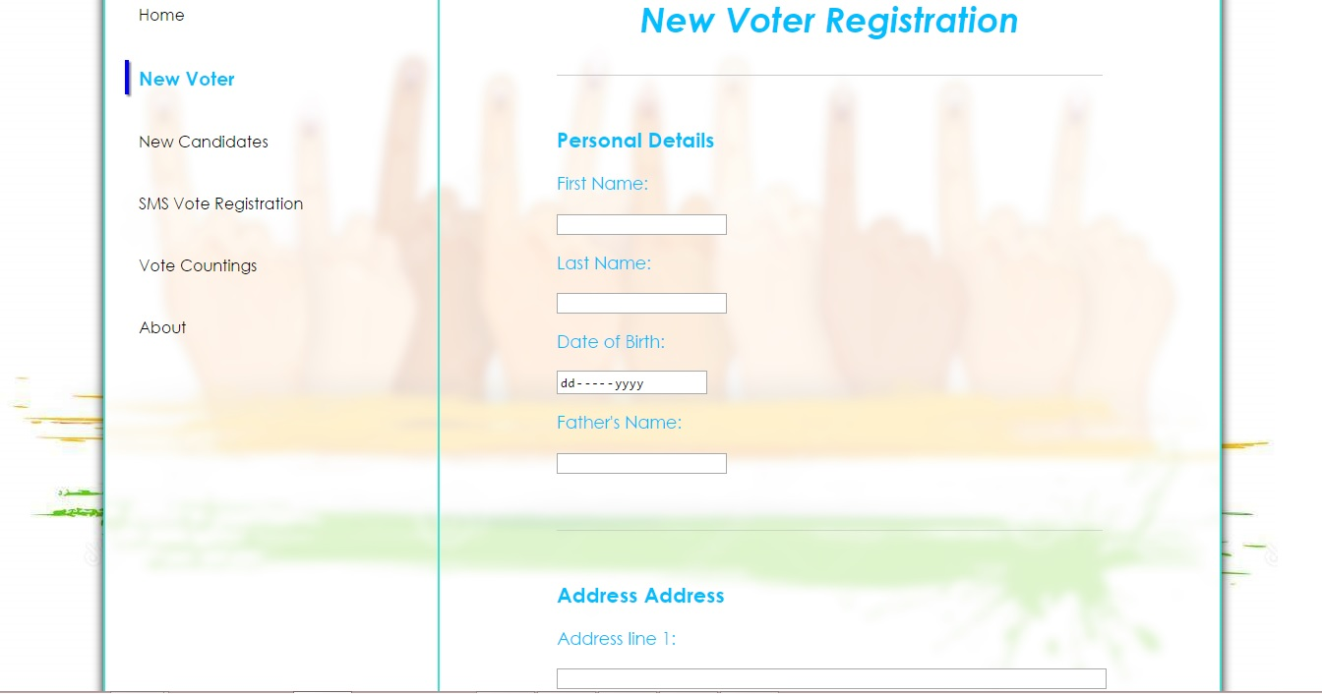
Figure 2: Screenshot of Voter Registration screen

- After receiving the Voter ID card with Voter ID number, the voter, if he wants to cast his vote through SMS, has to register separately for the same in the same website. The voter has to provide a phone number during this process. The form is validated after submitting and a Unique ID is generated to the user as a message to the phone number provided during registering for SMS voting.
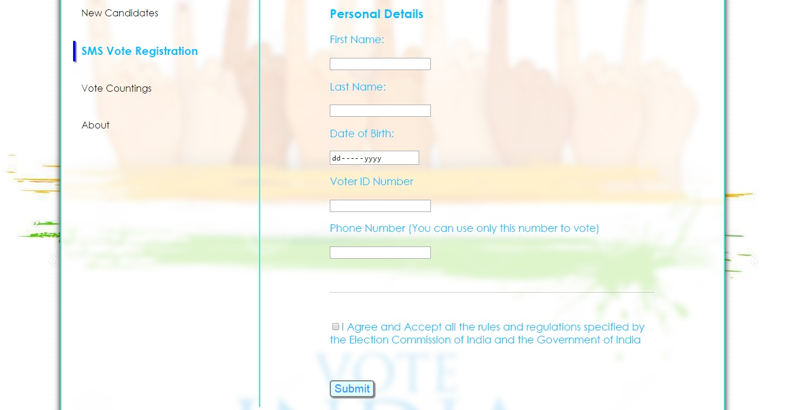
Figure 3: Screenshot of SMS Registration screen

Phase II: Voting Process

- On the day of voting, all the candidate details with respect to the region of the voter are sent as SMS from the Election Server (ES). The message consists of names of various candidates, party name and candidate code. The voter has to send the SMS in order to cast the vote. Voting message format is VOTE_voter id_unique id_candidate id. Once the vote is caste unique id will get expired in order to prevent false voting.
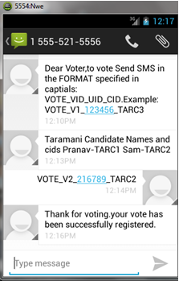
Figure 4: Screenshot of voting from a mobile phone

Phase III: Acquiring Region Wise Result

- On the day of result, the user has to send SMS in particular format in order to acquire the result. Message format is RESULT_voter id_unique id. The server will then respond to this message with the candidate name, party name and the number of votes for all candidates of the region which the user has specified in the message.
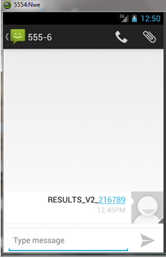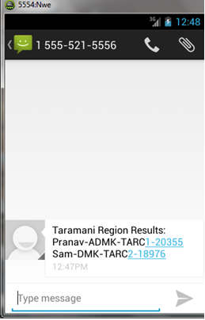
Figure 5: Screenshot of Result acquiring from mobile

ADVANTAGES:

- Can produce higher Vote outcome percentage in elections.

- Easily available to anyone who is interested to vote without standing in long queues, and hence saves lot of time.

- Highly responsive message system, to guide the registered voters as how to use the voting system and to provide acknowledgements.

- Instantaneously connected to the databases, and uses highly encrypted and secured database systems.

- Has well defined fall backs and backup measures. In-case any module of the System fails.

- CONCLUSION AND FUTURE IMPROVEMENTS

This paper proposes mobile phone SMS Voting (MPSV) with online mobile voting registration phase. Most important feature of our system is that it is suitable for countries with any number of region. System prevent double voting in case of casting ballots first from mobile phone and then from pooling booth. Proposed system is more efficient and reliable in the sense that data will be sent to the election commission server through secure SMS. Our system doesn’t need internet or any special hardware device which reduces the cost. System only requires mobile phone and SIM card. This system saves money and time requirement as in the traditional voting system. Also it is eco-friendly and avoids wastage of paper.

Also, our system is proposed only as an extension to the current system. Having a separate registration process for the SMS voters allows the proposed system to be integrated with the existing Electronic Voting or Paper Ballot Systems, thus enabling busy citizens and IT people to vote in an easy way, and also providing voting options to the eligible citizens, both at rural and urban areas. In future, as people embrace technology completely, this system could replace the existing systems and provide easy voting mechanisms in elections.

REFERENCES

- Paper 1: M-Vote: A Reliable and Highly Secure Mobile Voting System by Adel Khelifi, Yasmin Grisi, Dima Soufi, Dalya Mohanad published in 2013 Palestinian International Conference on Information and Communication Technology.
- Paper 2:An Efficient and Secure Mobile Phone Voting System by Mohib Ullah, Arif Iqbal Umar, Noor ul Amin, Nizamuddin published in 2013.
- Paper 3:A Secure Approach for Web Based Internet Voting System using Multiple Encryption by Prof.S.M. Jambhulkar Dept. Of Electronics Engg. R.G.C.E.R., Nagpur, India published in 2014 International Conference on Electronic Systems, Signal Processing and Computing Technologies.
- SMS Message and SMS Manager. Android API’s. Retrieved from Android website: http://developer.android.com/reference/android/telephony/SmsMessage.html
- Building a Cloud based SMS banking solution – Case Study. Retrieved from Infinite Website: http://www.infinite.com/resources/case-study/cloudbased-case-study
- Election Systems, Election Types, E-voting, Countries with Internet Voting. Retrieved from Wiki Website : http://www.wikipedia .com
- Gateway, SMS gateway mechanisms, Implementations. Retrieved from Stackoverflow:http://stackoverflow.com/questions/26467954/how-to-integrate-sms-gateway-with-the-server-of-parse-com.
- Election registration details. Retrieved from Indian Election Commission website: http://eci.nic.in/
- Encryption and security. Retrieved from http://www.phpaes.com

